PAISA BAZAAR BANKING FRAUD ANALYSIS
ALL-IN-ONE PROJECT DOCUMENT
Power BI Dashboard • DAX
PAGE 1  FRAUD OVERVIEW | PAGE 2  SUSPICIOUS BEHAVIOUR | PAGE 3  CUSTOMER RISK PROFILE | PAGE 4  EXECUTIVE MONITORING
1. PROJECT OBJECTIVE
The project analyzes customer credit and financial behaviour to identify risk patterns, compare customer segments, and create an executive fraud-risk monitoring dashboard. The dashboard supports prioritization and investigation; it does not prove that a customer committed fraud.The main objective of this project is to analyze customer credit and financial behaviour, identify areas where risk is concentrated, and provide management with an interactive dashboard for fraud-risk monitoring.
One important point I want to clarify is that this dashboard does not prove that a customer has committed fraud. Instead, it identifies customers and behaviours that show stronger risk signals and therefore may require closer monitoring.

2. PROJECT REQUIREMENTS FROM THE PROVIDED DOCUMENT
The project brief requires a visually appealing and clearly organized dashboard, appropriate visualizations, meaningful insights and data storytelling, user-friendly filters and navigation, and evidence of data cleaning/transformation. It also expects the presentation to cover the project objective, dataset, business problem, data preparation, EDA flow, key visualizations, business interpretation, challenges, conclusion and future improvements.
- Visual appeal and consistent design.
- Appropriate visualization choices and clear scaling.
- Meaningful insights and a clear data story.
- Interactive filters and smooth navigation.
- Data cleaning and transformation.
- EDA progression from univariate to bivariate to multivariate analysis.
- Business interpretation and actionable observations.
- Challenges, solutions, conclusion and future improvements.
3. BUSINESS PROBLEM
The business problem is to identify customer segments with stronger credit and financial-risk signals so that management can prioritize monitoring, review payment behaviour, assess credit exposure, and focus resources on higher-risk groups.

4. DATA / ANALYTICAL CONCEPTS
- Customer-level analysis using Customer_ID.
- Credit-risk classification using Credit_Score categories such as Good, Standard and Poor.
- Financial variables such as Annual_Income, Monthly_Inhand_Salary, Outstanding_Debt, Total_EMI_per_month and Amount_invested_monthly.
- Behavioural variables such as Delay_from_due_date, Num_Credit_Inquiries and Credit_Utilization_Ratio.
- Segmentation variables such as Age Group, Occupation, Payment_Behaviour and Credit_Mix.
- Repeated customer records make DISTINCTCOUNT important for unique-customer KPIs.
5. DATA PREPARATION & TRANSFORMATION
The dashboard uses transformed fields such as Age Group and measures for customer-level and portfolio-level KPIs. The project brief also expects discussion of missing values, duplicates, inconsistencies, cleaning steps and data types during the presentation.
- Create Age Group from Age.
- Use DISTINCTCOUNT for unique customer KPIs.
- Use measures for averages and percentages.
- Use filtered measures for High Risk, Monitor and Low Risk customer counts.
- Use slicers for interactive segmentation.
- Check unknown/missing categories before drawing business conclusions.
6. COMPLETE DAX MEASURES CREATED
Total Customers
Total Customers =
DISTINCTCOUNT(CreditData[Customer_ID])
High Risk Customers
High Risk Customers =
CALCULATE(
DISTINCTCOUNT(CreditData[Customer_ID]),
CreditData[Credit_Score] = "Poor"
)
High Risk %
High Risk % =
DIVIDE(
[High Risk Customers],
[Total Customers],
0
)
Average Credit Utilization %
Average Credit Utilization % =
AVERAGE(CreditData[Credit_Utilization_Ratio])
Average Delayed Payments
Average Delayed Payments =
AVERAGE(CreditData[Delay_from_due_date])
Average Credit Inquiries
Average Credit Inquiries =
AVERAGE(CreditData[Num_Credit_Inquiries])
Average Outstanding Debt
Average Outstanding Debt =
AVERAGE(CreditData[Outstanding_Debt])
Average Bank Accounts
Average Bank Accounts =
AVERAGE(CreditData[Num_Bank_Accounts])
Average Credit Cards
Average Credit Cards =
AVERAGE(CreditData[Num_Credit_Card])
Average Loans
Average Loans =
AVERAGE(CreditData[Num_of_Loan])
Average Annual Income
Average Annual Income =
AVERAGE(CreditData[Annual_Income])
Average Monthly Salary
Average Monthly Salary =
AVERAGE(CreditData[Monthly_Inhand_Salary])
Average EMI
Average EMI =
AVERAGE(CreditData[Total_EMI_per_month])
Average Investment
Average Investment =
AVERAGE(CreditData[Amount_invested_monthly])
Customers to Monitor
Customers to Monitor =
CALCULATE(
DISTINCTCOUNT(CreditData[Customer_ID]),
CreditData[Credit_Score] = "Standard"
)
Low Risk Customers
Low Risk Customers =
CALCULATE(
DISTINCTCOUNT(CreditData[Customer_ID]),
CreditData[Credit_Score] = "Good"
)

Overall Fraud Risk Score
Overall Fraud Risk Score =
ROUND(
([High Risk %] * 100) * 0.50 +
MIN([Average Delayed Payments] / 30 * 100, 100) * 0.25 +
MIN([Average Credit Inquiries] / 15 * 100, 100) * 0.25,
0
)
Risk Score Target
Risk Score Target =
70
Risk Category
Risk Category =
SWITCH(
TRUE(),
[Overall Fraud Risk Score] >= 70, "HIGH RISK",
[Overall Fraud Risk Score] >= 40, "MEDIUM RISK",
"LOW RISK"
)
7. CALCULATED COLUMN: AGE GROUP
Age Group =
SWITCH(
TRUE(),
CreditData[Age] >= 18 && CreditData[Age] <= 25, "18-25",
CreditData[Age] >= 26 && CreditData[Age] <= 35, "26-35",
CreditData[Age] >= 36 && CreditData[Age] <= 45, "36-45",
CreditData[Age] >= 46 && CreditData[Age] <= 55, "46-55",
CreditData[Age] >= 56, "55+",
"Unknown"
)
Age Group is a calculated column because Age is a row-level attribute. It allows the dashboard to compare meaningful age bands instead of individual ages.
8. WHY THESE DAX FUNCTIONS WERE USED
Function | Used For | Interview Explanation
DISTINCTCOUNT | Unique customers | The source contains repeated customer records, so I needed unique customer counts.
CALCULATE | Filtered customer counts | It modifies filter context, for example to isolate Poor credit-score customers.
DIVIDE | Percentages | It safely calculates ratios and handles division-by-zero.
AVERAGE | Financial/behavioural KPIs | It represents the typical customer level rather than the total.
SWITCH(TRUE()) | Age and risk bands | It evaluates multiple logical conditions in sequence.
MIN | Risk-score normalization | It caps normalized components at 100.
ROUND | Executive risk score | It presents the composite score as a clean executive number.

9. PAGE 1 – FRAUD OVERVIEW
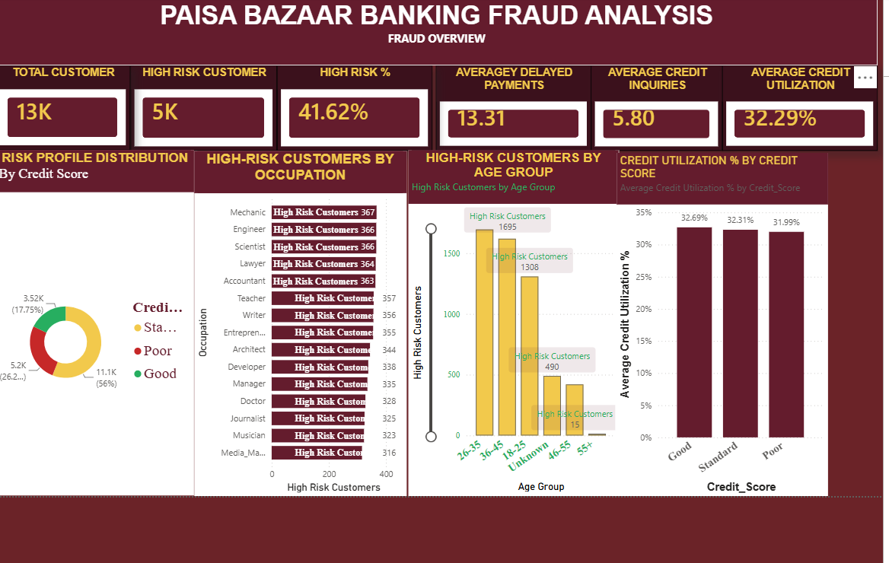
Story: First establish the overall risk landscape and identify where high-risk customers are concentrated.
KPI cards:
- Total Customer
- High Risk Customer
- High Risk %
- Average Delayed Payments
- Average Credit Inquiries
- Average Credit Utilization
Charts:
- Risk Profile Distribution by Credit Score
- High-Risk Customers by Occupation
- High-Risk Customers by Age Group
- Credit Utilization % by Credit Score
Main insights:
- Approximately 13K unique customers are represented on the overview.
- The dashboard shows approximately 5K high-risk customers and 41.62% High Risk.
- Risk concentration differs by occupation and age group.
- Credit utilization is a recurring financial-risk indicator.
Story: “Where is the risk?”
I start my analysis with the overall risk landscape. The first page gives management a quick overview of the customer portfolio using total customers, high-risk customers, high-risk percentage, delayed payments, credit inquiries and credit utilization.
KPI | Dashboard value
Total Customers | ≈ 13K
High Risk Customers | ≈ 5K
High Risk % | 41.62%
Average Delayed Payments | 13.31
Average Credit Inquiries | 5.80
Average Credit Utilization | 32.29%
I then break this risk down by credit score, occupation and age group. This helps answer not only how much risk exists, but also where the risk is concentrated. Credit utilization is a recurring financial-risk indicator.
Transition: “So, after identifying who appears to be at higher risk, the next question is: What are these customers actually doing financially?”
PAGE 1 – FRAUD OVERVIEW
Story: First establish the overall risk landscape and identify where high-risk customers are concentrated.
Total Customer
High Risk Customer
High Risk %
Average Delayed Payments
Average Credit Inquiries
Average Credit Utilization
Risk Profile Distribution by Credit Score
High-Risk Customers by Occupation
High-Risk Customers by Age Group
Credit Utilization % by Credit Score
Page 1 – Average Delayed Payments
Average Delayed Payments =
AVERAGE(CreditData[Delay_from_due_date])
Explanation: Returns the average number of days/units of delay represented in Delay_from_due_date. It is used as a behavioural risk indicator and as one component of the project risk score.
Type: Measure
Page 1 – Average Credit Inquiries
Average Credit Inquiries =
AVERAGE(CreditData[Num_Credit_Inquiries])
Explanation: Returns the average number of credit inquiries and provides a credit-seeking behaviour signal.
Type: Measure
Page 1 – Average Credit Utilization %
Average Credit Utilization % =
AVERAGE(CreditData[Credit_Utilization_Ratio])
Explanation: Returns the average utilization ratio. Format this measure as Percentage only if the stored values are decimals such as 0.32; if the source stores 32.29, do not apply an additional percentage conversion.
Type: Measure
Page 1 – Risk Profile Distribution
Customers by Credit Score =
DISTINCTCOUNT(CreditData[Customer_ID])
Explanation: Place CreditData[Credit_Score] on the category/legend and this measure in Values. The measure counts unique customers inside each credit-score filter context.
Type: Measure
Page 1 – High-Risk Customers by Occupation
High Risk Customers by Occupation =
[High Risk Customers]
Explanation: The Occupation field supplies the category context. The measure then counts Poor-score customers within each occupation.
Type: Measure
Page 1 – High-Risk Customers by Age Group
High Risk Customers by Age Group =
[High Risk Customers]
Explanation: Age Group supplies the category context, while the reused High Risk Customers measure counts Poor-score customers in each age band.
Type: Measure
Page 1 – Credit Utilization by Credit Score
Credit Utilization by Credit Score =
AVERAGE(CreditData[Credit_Utilization_Ratio])
Explanation: Credit_Score supplies the category context and the average utilization measure is recalculated for each credit-score group.
Type: Measure

PAGE 1 – FIELD PLACEMENT
Visual | Axis / Category | Values
Risk Profile Distribution | Credit_Score | [Customers by Credit Score]
High-Risk Customers by Occupation | Occupation | [High Risk Customers]
High-Risk Customers by Age Group | Age Group | [High Risk Customers]
Credit Utilization by Credit Score | Credit_Score | [Average Credit Utilization %]
Page 1 Visuals and DAX
- Risk Profile Distribution by Credit Score → Total Customers / High Risk Customers
- High-Risk Customers by Occupation → High Risk Customers
- High-Risk Customers by Age Group → High Risk Customers
- Credit Utilization by Credit Score → Average Credit Utilization %
- Top KPI cards → Total Customers, High Risk Customers, High Risk %, Average Delayed Payments, Average Credit Inquiries, Average Credit Utilization %

10. PAGE 2 – SUSPICIOUS BEHAVIOUR ANALYSIS
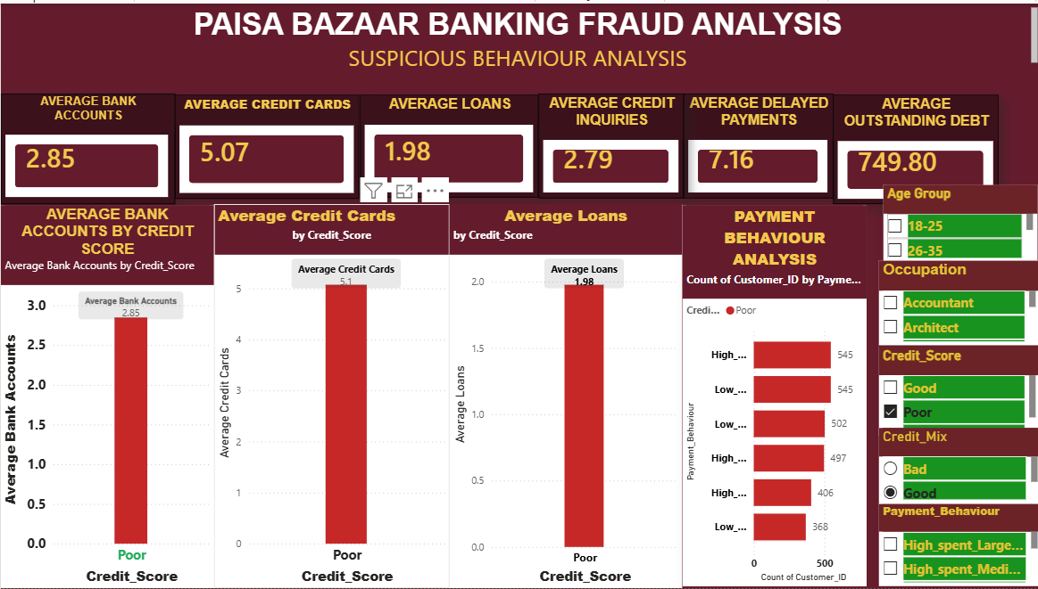
Story: Move from who is at risk to how customers behave financially.
KPI cards:
- Average Bank Accounts
- Average Credit Cards
- Average Loans
- Average Credit Inquiries
- Average Delayed Payments
- Average Outstanding Debt
Charts:
- Average Bank Accounts by Credit Score
- Average Credit Cards by Credit Score
- Average Loans by Credit Score
- Payment Behaviour Analysis
Main insights:
- Financial product exposure can be compared across credit-score groups.
- Delayed payments and credit inquiries provide additional behavioural signals.
- Payment behaviour can be filtered by Age Group, Occupation, Credit Score, Credit Mix and Payment Behaviour.

Story: “What behaviour is creating the risk?”
On the second page, I move from who is at risk to how customers behave financially. I analyze average bank accounts, credit cards, loans, credit inquiries, delayed payments and outstanding debt. The purpose is to compare these behaviours across different credit-score groups.
Multiple loans, high credit utilization, frequent credit inquiries and delayed payments can provide additional behavioural signals. I am not using one variable alone to declare someone fraudulent. Instead, I look at these indicators together to understand the customer's overall financial behaviour.
Interactive filters: Age Group, Occupation, Credit Score, Payment Behaviour and Credit Mix.
Transition: “Now that we understand the financial behaviour, I wanted to go one level deeper. What does the financial profile of these customers look like?”
PAGE 2 – SUSPICIOUS BEHAVIOUR ANALYSIS
Story: Move from who is at risk to how customers behave financially.
Average Bank Accounts
Average Credit Cards
Average Loans
Average Credit Inquiries
Average Delayed Payments
Average Outstanding Debt
Average Bank Accounts by Credit Score
Average Credit Cards by Credit Score
Average Loans by Credit Score
Payment Behaviour Analysis
Average Bank Accounts
Average Bank Accounts =
AVERAGE(CreditData[Num_Bank_Accounts])
Explanation: Calculates the average number of bank accounts. Credit_Score can be used as the axis to compare the average across risk groups.
Type: Measure
Average Credit Cards
Average Credit Cards =
AVERAGE(CreditData[Num_Credit_Card])
Explanation: Calculates the average number of credit cards and can be broken down by Credit_Score.
Type: Measure
Average Loans
Average Loans =
AVERAGE(CreditData[Num_of_Loan])
Explanation: Calculates average loan exposure and can be compared across Credit_Score groups.
Type: Measure
Page 2 – Payment Behaviour Customer Count
Payment Behaviour Customer Count =
DISTINCTCOUNT(CreditData[Customer_ID])
Explanation: Counts unique customers for each Payment_Behaviour category. Put Payment_Behaviour on the axis/category field.
Type: Measure
Page 2 – Average Outstanding Debt
Average Outstanding Debt =
AVERAGE(CreditData[Outstanding_Debt])
Explanation: Shows typical outstanding debt for the current filter context. It can be used as a KPI and as a supporting risk indicator.
Type: Measure
PAGE 2 – FIELD PLACEMENT
Visual | Axis / Category | Values
Average Bank Accounts by Credit Score | Credit_Score | [Average Bank Accounts]
Average Credit Cards by Credit Score | Credit_Score | [Average Credit Cards]
Average Loans by Credit Score | Credit_Score | [Average Loans]
Payment Behaviour Analysis | Payment_Behaviour | [Payment Behaviour Customer Count]

Page 2 Visuals and DAX
- Average Bank Accounts by Credit Score → Average Bank Accounts
- Average Credit Cards by Credit Score → Average Credit Cards
- Average Loans by Credit Score → Average Loans
- Payment Behaviour Analysis → Average Credit Inquiries, Average Delayed Payments and/or Average Outstanding Debt as used in the visual
- Credit Score is used as the category/axis, while the measures respond to the selected credit-score filter context.

11. PAGE 3 – CUSTOMER FRAUD-RISK PROFILE
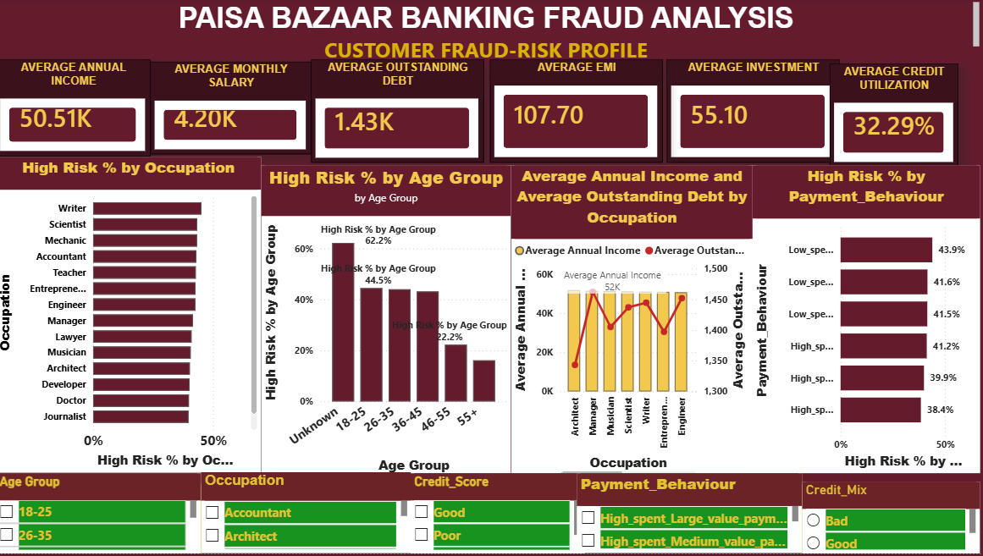
Story: Build the financial profile behind customer risk.
KPI cards:
- Average Annual Income
- Average Monthly Salary
- Average Outstanding Debt
- Average EMI
- Average Investment
- Average Credit Utilization
Charts:
- High Risk % by Occupation
- High Risk % by Age Group
- Average Annual Income and Average Outstanding Debt by Occupation
- High Risk % by Payment Behaviour
Observed age-group pattern:
- Unknown ≈ 62.2%
- 18–25 ≈ 44.5%
- 26–35 ≈ 44.0%
- 36–45 ≈ 43.1%
- 46–55 ≈ 22.2%
- 55+ ≈ 16.1%
Interpretation: the dashboard shows higher observed high-risk percentages in the younger identified age groups than in the older groups. The high Unknown percentage also signals a data-quality issue that should be investigated. This is an association in the dataset, not evidence that age causes fraud.
Story: “Who is behind the risk?”
Page 3 builds a deeper financial profile of the customer. I bring together annual income, monthly salary, outstanding debt, EMI, investment and credit utilization, and then compare these financial characteristics with occupation, age group and payment behaviour.
Age Group | Observed High Risk %
Unknown | ≈ 62.2%
18–25 | ≈ 44.5%
26–35 | ≈ 44.0%
36–45 | ≈ 43.1%
46–55 | ≈ 22.2%
55+ | ≈ 16.1%
The younger identified age groups show higher observed high-risk percentages than the older groups. However, the Unknown category has the highest observed percentage, which signals a data-quality issue that should be investigated. This is an association in the dataset, not evidence that age causes fraud.
PAGE 3 – CUSTOMER FRAUD-RISK PROFILE
Story: Build the financial profile behind customer risk.
Average Annual Income
Average Monthly Salary
Average Outstanding Debt
Average EMI
Average Investment
Average Credit Utilization
High Risk % by Occupation
High Risk % by Age Group
Average Annual Income and Average Outstanding Debt by Occupation
High Risk % by Payment Behaviour
Average Annual Income
Average Annual Income =
AVERAGE(CreditData[Annual_Income])
Explanation: Returns average annual income in the current filter context.
Type: Measure
Average Monthly Salary
Average Monthly Salary =
AVERAGE(CreditData[Monthly_Inhand_Salary])
Explanation: Returns average monthly in-hand salary in the current filter context.
Type: Measure
Average EMI
Average EMI =
AVERAGE(CreditData[Total_EMI_per_month])
Explanation: Returns the average monthly EMI obligation.
Type: Measure
Average Investment
Average Investment =
AVERAGE(CreditData[Amount_invested_monthly])
Explanation: Returns the average monthly investment amount.
Type: Measure
High Risk % by Occupation
High Risk % by Occupation =
DIVIDE(
[High Risk Customers],
[Total Customers],
0
)
Explanation: Occupation provides the filter context. The same High Risk % calculation is evaluated separately for each occupation.
Type: Measure
High Risk % by Age Group
High Risk % by Age Group =
DIVIDE(
[High Risk Customers],
[Total Customers],
0
)
Explanation: Age Group provides the filter context, so the percentage is calculated independently for each age band.
Type: Measure
High Risk % by Payment Behaviour
High Risk % by Payment Behaviour =
DIVIDE(
CALCULATE(
DISTINCTCOUNT(CreditData[Customer_ID]),
CreditData[Credit_Score] = "Poor"
),
DISTINCTCOUNT(CreditData[Customer_ID]),
0
)
Explanation: Calculates the percentage of unique customers classified as Poor within each Payment_Behaviour category.
Type: Measure
For the Income + Debt visual, use Occupation as the axis and [Average Annual Income] plus [Average Outstanding Debt] as Values. No special combined DAX measure is required.
6. AGE GROUP CALCULATED COLUMN
Age Group
Age Group =
SWITCH(
TRUE(),
CreditData[Age] >= 18 && CreditData[Age] <= 25, "18-25",
CreditData[Age] >= 26 && CreditData[Age] <= 35, "26-35",
CreditData[Age] >= 36 && CreditData[Age] <= 45, "36-45",
CreditData[Age] >= 46 && CreditData[Age] <= 55, "46-55",
CreditData[Age] >= 56, "55+",
"Unknown"
)
Explanation: Creates readable age bands from the row-level Age value. SWITCH(TRUE()) checks the ranges in order and assigns the first matching label.
Type: Calculated column
Create it under Modeling > New column.
Do not create this as a measure. A measure does not have one row-level Age value unless an aggregation or context is supplied.
The uploaded project explicitly retains Unknown as a data-quality category.
Page 3 Visuals and DAX
- High Risk % by Occupation → High Risk % with Occupation as category
- High Risk % by Age Group → High Risk % with Age Group as category
- Income vs Outstanding Debt by Occupation → Average Annual Income and Average Outstanding Debt
- High Risk % by Payment Behaviour → High Risk % with Payment Behaviour as category

12. PAGE 4 – FRAUD RISK MONITORING / EXECUTIVE VIEW
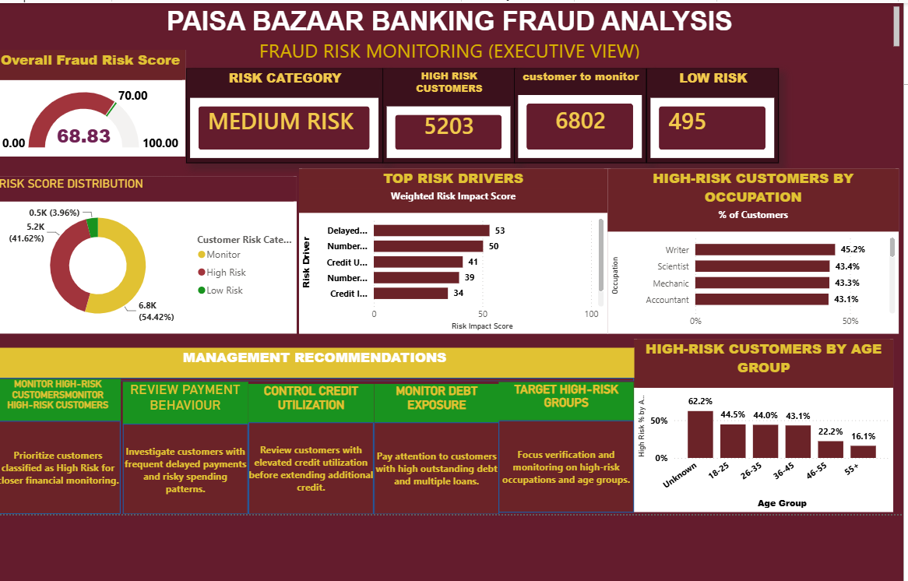
Story: Convert the detailed analysis into an executive monitoring view.
KPI cards:
- Overall Fraud Risk Score
- Risk Category
- High Risk Customers
- Customers to Monitor
- Low Risk Customers
Visuals:
- Overall Fraud Risk Score Gauge
- Risk Score Distribution
- Top Risk Drivers
- High-Risk Customers by Occupation
- High-Risk Customers by Age Group
- Management Recommendations
Current executive distribution:
Risk Category | Customers | Share
High Risk | 5,203 | 41.62%
Monitor | 6,802 | 54.42%
Low Risk | 495 | 3.96%
The dashboard shows an overall analytical risk score around 69, close to the 70 high-risk threshold. Under the project's defined thresholds, this is Medium Risk.
Story: “What should management do?”
After completing the detailed analysis, I bring everything together into an executive monitoring page. This page converts the analysis into a management-level view using the overall analytical risk score, risk category, high-risk customers, customers to monitor and low-risk customers.
PAGE 4 – FRAUD RISK MONITORING
PAGE 4 – FRAUD RISK MONITORING / EXECUTIVE VIEW
Story: Convert the detailed analysis into an executive monitoring view.
Overall Fraud Risk Score
Risk Category
High Risk Customers
Customers to Monitor
Low Risk Customers
Overall Fraud Risk Score Gauge
Risk Score Distribution
Top Risk Drivers
High-Risk Customers by Occupation
High-Risk Customers by Age Group
Management Recommendations
Overall Fraud Risk Score – PROJECT DEFINED FORMULA
Overall Fraud Risk Score =
ROUND(
([High Risk %] * 100) * 0.50 +
MIN([Average Delayed Payments] / 30 * 100, 100) * 0.25 +
MIN([Average Credit Inquiries] / 15 * 100, 100) * 0.25,
0
)
Explanation: Combines three project-defined signals: High Risk % (50% weight), delayed payments (25%) and credit inquiries (25%). MIN caps the latter normalized components at 100, and ROUND returns a whole-number executive score.
Type: Measure
Risk Score Target
Risk Score Target =
70
Explanation: Defines 70 as the target/threshold used by the project's gauge and risk-category logic.
Type: Measure or constant measure
Risk Category
Risk Category =
SWITCH(
TRUE(),
[Overall Fraud Risk Score] >= 70, "HIGH RISK",
[Overall Fraud Risk Score] >= 40, "MEDIUM RISK",
"LOW RISK"
)
Explanation: Converts the numerical risk score into three executive labels. Scores of 70 or more are High Risk, 40–69 are Medium Risk, and below 40 are Low Risk.
Type: Measure
PAGE 4 – RISK SCORE DISTRIBUTION
For a donut chart with one Risk Category field and one measure, create the following disconnected calculated table and measure.
Risk Category Table
Risk Category Table =
DATATABLE(
"Risk Category", STRING,
{
{"High Risk"},
{"Monitor"},
{"Low Risk"}
}
)
Explanation: Creates three display categories for the executive distribution visual. This table is intentionally disconnected from CreditData.
Type: Calculated table
Risk Category Customers
Risk Category Customers =
SWITCH(
SELECTEDVALUE('Risk Category Table'[Risk Category]),
"High Risk", [High Risk Customers],
"Monitor", [Customers to Monitor],
"Low Risk", [Low Risk Customers],
0
)
Explanation: Reads the selected category from the disconnected table and returns the corresponding customer KPI.The Risk Category Customers measure acts as the bridge that tells Power BI which customer-count measure to display for the selected category
Type: Measure
Donut/column chart: Legend/Axis = Risk Category Table[Risk Category]; Values = [Risk Category Customers].
PAGE 4 – TOP RISK DRIVERS
The uploaded screenshot shows a Top Risk Drivers visual. A disconnected driver table plus SWITCH measure is a clean way to reproduce it.
Risk Driver Table
Risk Driver Table =
DATATABLE(
"Risk Driver", STRING,
{
{"Delayed Payments"},
{"Number of Loans"},
{"Credit Utilization"},
{"Number of Credit Cards"},
{"Credit Inquiries"}
}
)
Explanation: Creates the driver labels displayed on the chart.
Type: Calculated table
Risk Driver Score
Risk Driver Score =
SWITCH(
SELECTEDVALUE('Risk Driver Table'[Risk Driver]),
"Delayed Payments",
MIN(DIVIDE([Average Delayed Payments], 30, 0) * 100, 100),
"Number of Loans",
MIN(DIVIDE([Average Loans], 5, 0) * 100, 100),
"Credit Utilization",
MIN([Average Credit Utilization %], 100),
"Number of Credit Cards",
MIN(DIVIDE([Average Credit Cards], 10, 0) * 100, 100),
"Credit Inquiries",
MIN(DIVIDE([Average Credit Inquiries], 15, 0) * 100, 100),
0
)
It converts different risk factors into a common 0–100 score so they can be displayed together in your Top Risk Drivers chart.
Risk Driver | Benchmark | Calculation
Delayed Payments | 30 | Average Delays ÷ 30 × 100
Number of Loans | 5 | Average Loans ÷ 5 × 100
Credit Utilization | 100 | Direct utilization score
Credit Cards | 10 | Average Cards ÷ 10 × 100
Credit Inquiries | 15 | Average Inquiries ÷ 15 × 100
MIN(...,100) makes sure the score doesn't go above 100.

Example: Credit Inquiries
If:
Average Credit Inquiries = 5.80
then:
5.80 ÷ 15 × 100 = 38.67
So the Credit Inquiries Risk Driver Score = 38.67.

What does SWITCH do?
SWITCH checks which driver is selected in your Risk Driver Table.
For example:
Selected = "Credit Inquiries"
➡️ Power BI uses:
MIN(DIVIDE([Average Credit Inquiries], 15, 0) * 100, 100)
If Delayed Payments is selected, it uses the delayed-payment calculation instead.

explanation
“IT created a Risk Driver Score to normalize different financial and behavioural risk indicators onto a common 0–100 scale. I used SWITCH to select the appropriate calculation for each risk driver and MIN to cap the score at 100. The benchmarks are project-defined analytical values.”
Important: These benchmarks, such as 30 days, 5 loans and 15 inquiries, are custom values defined for your project, not official banking fraud thresholds.

Explanation: Normalizes the selected driver to a project-defined 0–100 scale so the drivers can be compared in one visual. These normalization thresholds are analytical choices for the project, not official banking thresholds.
Type: Measure

Example: Credit Inquiries
[High Risk Customers],
[Total Customers],
0
)
Explanation: Use Occupation or Age Group as the axis. Power BI evaluates the same measure separately for each category.
Type: Measure
Format as Percentage with 2 decimal places.
Occupation axis + [High Risk %] gives High Risk % by Occupation.
Age Group axis + [High Risk %] gives High Risk % by Age Group.

Page 4 Visuals and DAX
- Overall Fraud Risk Score Gauge → Overall Fraud Risk Score; target → Risk Score Target
- Risk Score Distribution → High Risk Customers, Customers to Monitor and Low Risk Customers
- Top Risk Drivers → Average Delayed Payments, Average Credit Inquiries and High Risk %
- Risk Category → Risk Category measure
- Management Recommendations → Text/shape content based on the dashboard findings; no DAX measure is required.

13. TOP RISK DRIVER INSIGHTS
- Delayed payments are one of the strongest visible risk drivers.
- Number of loans contributes to the overall risk-driver view.
- Credit utilization is a recurring exposure indicator.
- Number of credit cards and credit inquiries add further context to customer risk.
- Risk drivers should be interpreted together rather than as proof of fraud from one variable.
14. MANAGEMENT RECOMMENDATIONS
- Monitor high-risk customers with multiple simultaneous risk indicators.
- Review customers with repeated delayed payments and risky spending patterns.
- Review elevated credit utilization before extending additional credit.
- Pay attention to customers with high outstanding debt and multiple loans.
- Focus verification and monitoring on high-risk occupations and age groups.
15. COMPLETE BUSINESS INSIGHTS
- 41.62% of customers are classified as high risk under the dashboard definition.
- The Monitor category is the largest group at 54.42%.
- The Low Risk group is comparatively small at 3.96%.
- Delayed payments and credit utilization are important monitoring indicators.
- Credit inquiries add a credit-seeking behaviour signal.
- Observed high-risk percentages vary substantially across age groups.
- Observed high-risk percentages vary across occupations.
- Income, salary, debt, EMI and investment provide financial context around customer risk.
- The executive score is close to the high-risk threshold, so targeted monitoring is appropriate.
- The dashboard is a risk-monitoring tool, not a fraud-confirmation system.
16. EDA STORY: UNIVARIATE → BIVARIATE → MULTIVARIATE
- Univariate: understand individual variables such as Age, Income, Debt, Credit Score and Payment Behaviour.
- Bivariate: compare risk against Occupation, Age Group, Credit Score and Payment Behaviour.
- Multivariate: connect income, debt, utilization, payment behaviour, occupation and age in the risk profile.
- Executive synthesis: convert the strongest signals into Page 4 risk monitoring.
This sequence follows the project brief's requirement to explain how each analytical stage helped uncover deeper insights.
17. FILTERS & NAVIGATION
- Age Group
- Occupation
- Credit Score
- Payment Behaviour
- Credit Mix
- Page Navigator for Fraud Overview, Suspicious Behaviour, Customer Fraud-Risk Profile and Fraud Risk Monitoring.
- In Power BI Desktop editing mode, Ctrl + Click a navigator button to test navigation.

PAGE-WISE QUICK MAP
Page | Main Business Question | Main DAX
Page 1 – Fraud Overview | Where is risk concentrated? | Customer counts, High Risk %, averages, Age Group
Page 2 – Suspicious Behaviour | How do customers behave financially? | Bank accounts, cards, loans, inquiries, delays, debt
Page 3 – Customer Fraud-Risk Profile | What financial profile sits behind risk? | Income, salary, debt, EMI, investment, utilization, High Risk %
Page 4 – Executive View | What should management monitor? | Risk score, category, distribution, risk drivers, High Risk %
18. PRESENTATION SCRIPT
Opening: This is a banking customer risk-analysis project built in Power BI. The objective is to identify customer segments with stronger financial and behavioural risk signals and provide management with an interactive monitoring dashboard.
Problem: The main business question is where risk is concentrated, what behaviours are associated with the risk, and which customer segments should receive closer monitoring.
Page 1: Page 1 establishes the risk landscape. I use unique customer counts, high-risk counts and percentages, then analyze occupation, age group and credit utilization.
Page 2: Page 2 investigates suspicious financial behaviour by comparing bank accounts, credit cards, loans and payment behaviour across credit-score groups.
Page 3: Page 3 builds a deeper customer profile using income, salary, debt, EMI, investment and credit utilization, then connects those variables with occupation, age and payment behaviour.
Page 4: Page 4 is the executive monitoring view. It summarizes the analytical risk score, risk category, customer distribution, top risk drivers and recommended management actions.
Conclusion: The analysis indicates a substantial high-risk and monitor population. Delayed payments, utilization and credit-seeking behaviour are important indicators, while age and occupation show different observed risk concentrations. The dashboard therefore supports targeted monitoring rather than a one-size-fits-all approach.
19. CHALLENGES & HOW THEY WERE HANDLED
- Repeated customer records: handled with DISTINCTCOUNT for unique-customer KPIs.
- Single-value Age error: solved by creating Age Group as a calculated column instead of incorrectly using raw Age in a measure.
- Risk percentages: handled with DIVIDE and filtered measures.
- Dashboard repetition: Page 2 was kept to four main charts to avoid duplicating the same analysis.
- Navigation: Page Navigator was added for all four pages.
- Executive gauge target: a target of 70 was defined for the custom risk-score scale.
- Unknown age category: retained as an explicit category so the data-quality signal remains visible.

Final Presentation Conclusion
To conclude, my Paisa Bazaar Banking Fraud Analysis project uses Power BI and DAX to convert customer financial and behavioural data into actionable risk insights.
I started by identifying the overall risk population, then analyzed financial and payment behaviour, followed by a deeper customer profile using income, debt, EMI, investment, occupation and age.
Finally, I created an executive monitoring dashboard containing a custom analytical risk score, risk distribution, risk drivers and management recommendations.
The dashboard shows 41.62% of customers classified as high risk and 54.42% in the Monitor category.
The key message from my analysis is that risk should not be judged using a single variable. Delayed payments, credit utilization, credit inquiries, loans, debt and customer characteristics should be considered together.
Therefore, the dashboard supports targeted risk monitoring and better management decisions rather than simply labeling customers as fraudulent.

20. INTERVIEW QUESTIONS & SHORT ANSWERS
Why did you use DISTINCTCOUNT?
Because the same customer can appear in multiple records, so COUNT would overstate unique customers.
Why did you use CALCULATE?
To modify filter context and calculate customer counts for specific risk categories.
Why use DIVIDE?
It safely handles division-by-zero when calculating percentages.
Why use AVERAGE?
To show the typical customer level for financial and behavioural measures.
Why create Age Group?
To make age analysis easier to interpret and visualize.
Why these charts?
They directly answer the business questions and progress from distribution to comparison and deeper profiling.
What is the most actionable insight?
A large Monitor and High Risk population means risk-based monitoring should be prioritized, with attention to delayed payments and credit exposure.
Is the risk score official fraud probability?
No. It is a custom analytical index created for this project.
What would you do next?
Add predictive modelling, investigate missing/unknown data, validate risk drivers, and build more advanced monitoring or alerting.
21. CONCLUSION & FUTURE IMPROVEMENTS
The completed dashboard creates a logical four-page story: identify the risk landscape, investigate behaviour, profile customers, and monitor risk at executive level.
- Future improvement: predictive modelling for probability of high-risk classification.
- Future improvement: customer-level risk scoring with a clearly defined latest-period rule.
- Future improvement: deeper missing-data and anomaly analysis.
- Future improvement: automated alerts for significant risk changes.
- Future improvement: trend analysis over time.
- Future improvement: validate the custom risk score against a labelled fraud outcome if such a label becomes available.
22. FINAL ONE-MINUTE SUMMARY
“My Paisa Bazaar Banking Fraud Analysis project uses Power BI and DAX to analyze customer credit and financial behaviour. I first identified the overall risk population, then investigated financial and payment behaviour, followed by a deeper customer profile using income, debt, EMI, investment, occupation and age. Finally, I created an executive risk-monitoring page with a custom analytical risk score, risk distribution, risk drivers and management recommendations. The dashboard shows 41.62% high-risk customers and 54.42% in the monitor category. The key message is that risk should be prioritized using multiple financial and behavioural indicators rather than a single variable.”
23. SOURCE / PROJECT-BRIEF ALIGNMENT
The supplied project brief requires visual appeal, appropriate visualization, meaningful insights, interactivity, data preparation, a clear EDA sequence, key visualization explanations, business interpretation, challenges, conclusion and future improvements. This consolidated document organizes the completed dashboard work around those requested sections.

SCREENSHOT REFERENCE
Screenshot 1: FRAUD OVERVIEW
Screenshot 2: SUSPICIOUS BEHAVIOUR ANALYSIS
Screenshot 3: CUSTOMER FRAUD-RISK PROFILE
Screenshot 4: FRAUD RISK MONITORING / EXECUTIVE VIEW

